Bear / Doll / Animal  Size  Guidelines | Hard Board & Millboard Disc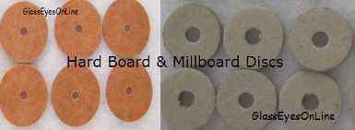 | T-Pin, Connecting Pin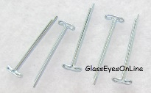 | Washer  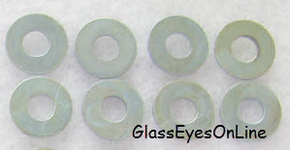
2 inch to 4 inch | 7mm (approx. 5/16 inch or 0.276 inch) diameter | (Length=21mm or 7/8 inch) (T=5mm or 3/16 inch) | 7mm (6/16 inch or 0.276 inch) diameter. Center Hole 3mm
4 inch to 5 inch | 10mm (approx. 3/8 inch or 0.394 inch) diameter | (Length=21mm or 7/8 inch) (T=5mm or 3/16 inch) | 7mm (6/16 inch or 0.276 inch) diameter. Center Hole 3mm
5 inch to 6 inch | 12mm (approx. 1/2 inch or 0.472 inch) diameter | (Length=25mm or 15/16 inch) (T=6mm or 1/4 inch) | 7mm (6/16 inch or 0.276 inch) diameter. Center Hole 3mm
6 inch to 8 inch | 15mm (approx. 9/16 inch or 0.591 inch) diameter | (Length=25mm or 15/16 inch) (T=6mm or 1/4 inch) | 7mm (6/16 inch or 0.276 inch) diameter. Center Hole 3mm
8 inch to 9 inch | 20mm (approx. 3/4 inch or 0.787 inch) diameter | (Length=34mm or 1 and 5/16 inch) (T=8mm or 5/16 inch) | 11mm (7/16 inch or 0.433 inch) diameter Center hole 4mm
9 inch or 10 inch | 25mm (approx. 1 inch or 0.984 inch) diameter | (Length=34mm or 1 and 5/16 inch) (T=8mm or 5/16 inch) | 11mm (7/16 inch or 0.433 inch) diameter Center hole 4mm
11 inch or 12 inch | 30mm (approx. 1 and 1/4 inch) diameter | (Length=34mm or 1 and 5/16 inch) (T=8mm or 5/16 inch) | 11mm (7/16 inch or 0.433 inch) diameter Center hole 4mm
13 inch or 14 inch | 35mm (approx. 1 and 3/8 inch) diameter | (Length=34mm or 1 and 5/16 inch) (T=8mm or 5/16 inch) | 11mm (7/16 inch or 0.433 inch) diameter Center hole 4mm
14 inch or 15 inch | 40mm (approx. 1 and 9/16 inch) diameter | (Length=36mm or 1 and 13/32) (T=10mm or 3/8 inch) | 19mm (3/4 inch or 0.748 inch) diameter Center hole 4mm
16 inch | 45mm (approx. 1 and 3/4 inch) diameter | (Length=36mm or 1 and 13/32) (T=10mm or 3/8 inch) | 19mm (3/4 inch or 0.748 inch) diameter Center hole 4mm
 | 50mm (approx. 2 inch) diameter | (Length=36mm or 1 and 13/32) (T=10mm or 3/8 inch) | 19mm (3/4 inch or 0.748 inch) diameter Center hole 4mm
 | 55mm (approx. 2 and 11/64 inch) diameter | (Length=36mm or 1 and 13/32) (T=10mm or 3/8 inch) | 19mm (3/4 inch or 0.748 inch) diameter Center hole 4mm
20 inch | 60mm (approx. 2 and 23/64 inch) diameter | (Length=36mm or 1 and 13/32) (T=10mm or 3/8 inch) | 19mm (3/4 inch or 0.748 inch) diameter Center hole 4mm
 | 70mm (approx. 2 and 3/4 inch) diameter | (Length=45mm or 1 and 3/4) (T=11mm or 7/16 inch) | 19mm (3/4 inch or 0.748 inch) diameter Center hole 4mm
 | 75mm (approx. 3 inch) diameter | (Length=45mm or 1 and 3/4) (T=11mm or 7/16 inch) | 19mm (3/4 inch or 0.748 inch) diameter Center hole 4mm

